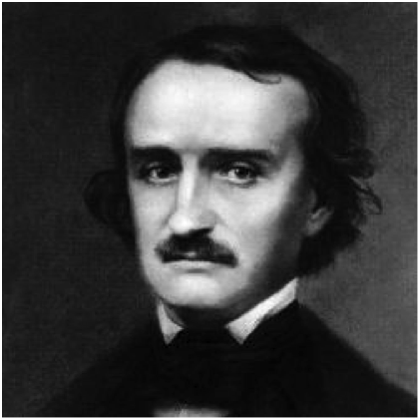

We have been discussing Edgar Allan Poe to jumpstart our “Thrills and Chills”
unit. However, our job now is going to be researching one particular aspect of
Edgar Allan Poe's life: his mysterious death. We will be researching Poe's death
in order to create a presentation that will be presented in
front of the class. Your job is to argue why your death theory is correct and
disprove other theory.
Your group will be assigned a specific death theory. For your assigned death theory, you will be creating an argumentative presentation that proves why your death theory is correct and why two other theories are incorrect.

Alcoholism Tuberculosis Cooping (Foul Play)
Brain Lesions Heart Problems Rabies

An example PowerPoint will be provided for you as a model; however, you should use other arguments to prove why your theory is correct and why others are incorrect, not the ones presented on the example. A rubric explaining the grading process is located on the back of this paper. There will also be a 20-point group evaluation that will be included in the Projects/Papers grade.

This assignment will be presented on October 28 and 29.

Timeline for This Project:

- October 22/23: Introduction to project
- October 23: Group selection and theory assignment
- October 23-27: In class group work
- October 28-29: Presenting Project in class and group evaluations

Students should be using Google Docs/Presentations in order to create their presentations. If it is not properly shared with me, it will be marked late and be a letter grade deduction. These documents should be shared with cathryn_dymek@hcpss.org.

For additional information, please refer to my website:
www.dymekhcms.weebly.com

I have read and understood the above project and the timeline. I understand that I will need to work outside of class to complete this project. In addition, I understand that saving and sharing work appropriately and correctly is my group’s responsibility.

Student Signature: _________________________________________________________________
Parent Signature: __________________________________________________________________

Edgar Allan Poe Death PowerPoint and Presentation Rubric

Mastery | Getting There… | Needs Improvement | Score
Presenters give sufficient evidence to support their death theory’s validity  20 | Presenters give evidence to support their death theory’s validity, but the evidence may not fully support it.  15 | There is an attempt to provide evidence that supports the death theory.  0-10
Presenters effectively use argument strategies in order to disprove 2 other possible death theories.  20 | Presenters use argument strategies to disprove two other theories, but their arguments may be lacking support.  15 | Presenters have only one argument or arguments do not effectively disprove other death theories.  0-10
Presenters are speaking loudly and clearly. Presenters have appropriate amount of eye contact. Presenters demonstrate a thorough understanding of their topic.  20 | Presenters may be speaking loudly and clearly, but may be difficult to hear at times. Presenters may need more eye contact. Presenters demonstrate some understanding of their topic.  15 | Presenters need to speak louder and more clearly. Presenters were difficult to hear at times. Presenters need to improve eye contact. Presenters struggle to demonstrate understanding.  0-10
A list of at least four sources is provided at the end of the PowerPoint. Citations for sources and photographs are in MLA format and are formatted correctly.  10 | A list of sources is provided at the end of the PowerPoint. There may not be four sources or they may not be formatted correctly.  5 | A list of sources is provided at the end, but there are only two or fewer sources. They sources are not formatted correctly. OR There is not a list of sources provided at the end.  4-0
PowerPoint is attractive (with pictures) and easy to read.  10 | PowerPoint may be attractive and easy to read.  5 | PowerPoint is difficult to read (coloring/font) and does not have pictures  2.5

SCORE: ____________/80

