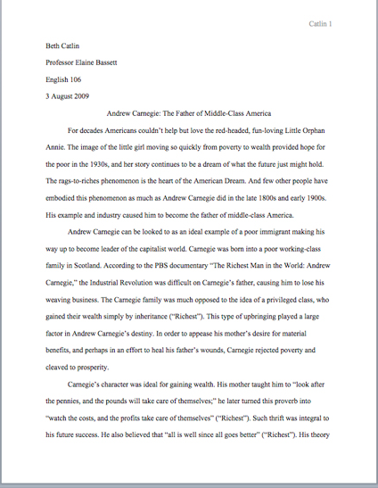
MLA stands for the Modern Language Association. This association provides a specific
format for those in the English field to cite their references.
When you are writing a paper in MLA format, all work should be:
- Times New Roman font
This is how a MLA paper should be formatted. First is your name, followed by your instructor’s name, your class, and the date (date month year). Your last name and the page number should be on the top right-hand side of your paper. The title should be centered and should not be italicized or underlined.
- Size 12 font
- Double-spaced
- One-inch margins
- Left justified
- One-inch tabs

At the end of your paper or assignment, you should include a Works Cited page. All
citations should be in alphabetical order using the author’s last name.

Book with One Author

Last name, First name. Title of Book. City of Publication: Publisher, Year of Publication. Medium of Publication.
If the citation goes onto a second line, the second line should be indented. This is called a hanging indent. You can create a hanging indent for going to “Format,” selecting “Paragraph,” and under “Indentation,” choose “Special.” One of the options will be “hanging.”

For Example
Rowling, J. K. Harry Potter and the Sorcerer's Stone. New York: A.A. Levine, 2008. Print.

Book with More than One Author
First author has last name first. Authors after that get First name Last name.

Lastname, Firstname, and Firstname Lastname. Title of Book. City of Publication: Publisher, Year of Publication. Medium of Publication.
Website
This should format should be used when citing an entire website (multiple pages, links, etc.). When citing a website, it often helps to scroll to the bottom of the Home page. There is usually an “About Us” link at the bottom. This usually provides the user with many of the required cited information.
If information is not provided, then omit it from your citation.

Editor, author, or compiler name (if available). Name of Site. Version number. Name of institution/organization affiliated with the site (sponsor or publisher), date of resource creation (if available). Medium of publication. Date of access.

For Example:
The Purdue OWL Family of Sites. The Writing Lab and OWL at Purdue and Purdue U, 2008. Web. 23 Apr. 2008.
An Article (Found Online)
URL articles are no longer required in MLA citations because URL addresses constantly change; however, you still may be required to cite one. If there is no date given, you would write n.d.

Lastname, Firstname. “Article Title in Quotations.” Name of Periodical. Publisher/Sponsor of Periodical. Date publish. Medium of Publication. Date accesses. URL
For Example
Kepner, Tyler. "Closer’s Pickoff Surprised Even the Red Sox." New York Times. New York Times, 28 Oct. 2013. Web. 29 Oct. 2013. <www.nytimes.com>.
An Image including a Painting, Sculpture, or Photograph
Many people choose to use Google in order to find images. If you do this, you need to be sure that reuse is allowed. To be sure that your image is not subject to copyright laws, you can do an Advanced Google search. Under “Usage Rights,” be sure to select “Free to Use and Share.” This means that you are allowed to use this particular image in your paper or other assignment.

Lastname, Firstname. Title of Image. Date or Year Taken or Published. Type of Image. Website Title. Publisher or Sponsor. Date published online. Medium of Publication. Date accessed. <URL>.
For Example
Fulton, Maurice G. Edgar Allan Poe--Southern Life in Southern Literature. 1917. Photograph. Southern Life in Southern Literature. Southern Literature, 3 Apr. 2012. Web. 29 Oct. 2013. <http://www.archive.org/details/southernlife00fultrich>.
For More information or for other types of sources visit
https://owl.english.purdue.edu/owl/section/2/11/
http://www.library.cornell.edu/resrch/citmanage/mla
http://www.csus.edu/owl/index/mla/mla_format.htm
http://www.mla.org/

Using online citation generators are okay to use;
HOWEVER, they ARE NOT 100% accurate.
It is YOUR responsibility to create a correct citation.

http://citationmachine.net
http://www.easybib.com/
http://www.noodletools.com/

